**Question 1: the relationship between the individual and the community in African World view**

Outline:

1.0 introduction

2.0 the western view of person and the African view of person

3.0 the western view of community and the African view of community

4.0 personhood in African Worldview

5.0 personhood and existentialism in African Thought

6.0 Evaluation and conclusion

**1.0 introduction**

Menkiti in his article “personhood and community in African thought”, argues that in traditional African thought, the community takes precedence over the individual. Personhood, in his view, is not an inherent quality but is achieved through a process of incorporation into the community.

In the African community, the individual persons exists because there is a community. In other words, it is the community that gives existence to the individual persons. As a result of this, the community is held as supreme and the individuals strive as much as possible to be connected to the community

Menkiti uses Mbiti's dictum, "I am because we are," as a foundation to support this communitarian perspective. This gives a sense or notion of ‘communalism’, a type of relationship where citizens live together in love, share things together, care for each other. This is in direct contrast with the western method of individualism where common goals are downplayed over individual goals.

In the following sections, we would discuss more on these

**2.0 Menkiti’s idea of a person as “an empowering community**Menkiti's concept of an "empowering community" refers to the idea that an individual's personhood is defined and nurtured by their community. In this sense, the community plays an active role in shaping, guiding, and enabling individuals to develop into full persons.

For Menkiti, the "empowering" aspect lies in how the community provides the moral framework, cultural values, and social structures that help individuals grow, fulfill their roles, and achieve personhood. A person is not just born but is made through participation in communal life, such as fulfilling responsibilities, observing traditions, and contributing to the collective good.

The community, therefore, is not just a passive background but an active, empowering force that ensures the flourishing of its members as complete persons.

**3.0 the idea of “constitual nature” in African Community**In the context of Menkiti's philosophy, the "constitutive nature" refers to the idea that the community is fundamental in forming or constituting an individual's personhood. This means that a person is not seen as an isolated entity but as someone whose identity, values, and sense of self are deeply shaped by and dependent on their community. The constitutive nature of the community highlights its role as the foundation or essence of what it means to be a person, emphasizing that an individual's personhood is built through relationships, cultural norms, and communal engagement.

**2.0 the western view of person and the African view of person**

The Western perspective generally emphasizes individual autonomy, rights, and self-definition, focusing on the inherent qualities of rationality and will to define personhood.

Critics of Menkiti, such as Kwame Gyekye, also argue against the notion that community solely defines personhood. Gyekye emphasizes that while community plays a crucial role in a person's life, an individual is inherently a person due to their intrinsic qualities, which exist independently of communal recognition or validation.

In contrast, the African view, particularly as articulated by Menkiti, frames personhood in the context of communal relationships, a person is defined through their membership and roles within the community. This relationship underscores valuing social responsibilities and collective identity over individualism.

The Western view of personhood is often minimal and individualistic, while the African view is maximal and relational.

**4.0 Menkiti’s notion of minimal and maximal**

Minimal Personhood : This term describes the Western view of personhood, where an individual is considered a person simply because they possess certain inherent qualities, such as rationality or will. In this view, personhood is seen as a minimal, often individualistic condition, focusing on the individual as a self-contained entity with inherent rights. The person is recognized as a person from birth due to these inherent qualities, regardless of social context.

Maximal Personhood: This refers to the African view, where personhood is not automatically given but is achieved through one's integration into the community. It emphasizes the relational aspect of personhood, meaning that an individual is defined through their interactions, roles, and responsibilities within the social and communal framework. Personhood is maximal when an individual is fully realized through participation in and contribution to the community, embodying communal values and ethics.

**3.0 the western view of community and the African view of community**

Menkiti also distinguished between the African world view of a community and the western world view of the community. For the westerners, community is made up of different individual persons. Therefore, without these individuals, the community would not exist.

The story is totally different in the African view of the community. The Africans sees personhood as flowing from the community. This is to say that individual persons exist because there is a community and without the community, the individuals will not exist. We can see this in the diagram below

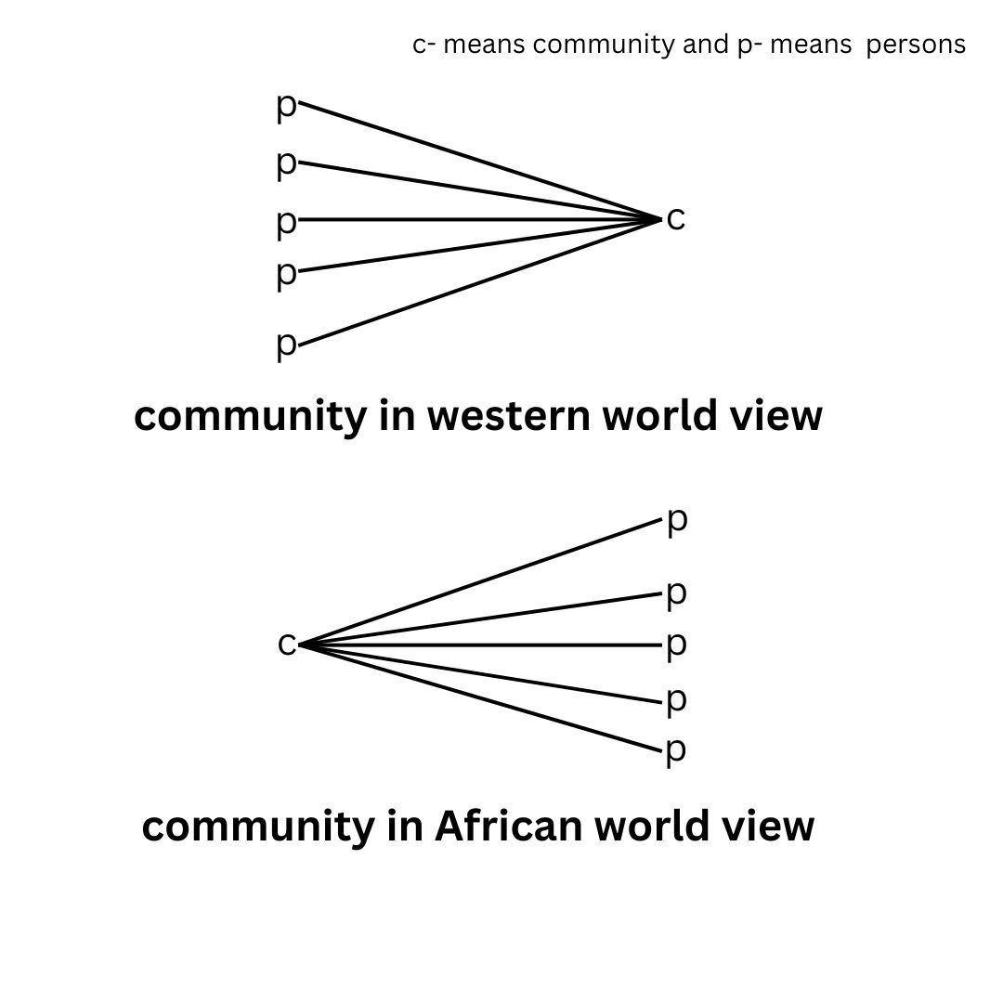

**4.0 personhood in African Worldview**

Menkiti argues that in traditional African thought, personhood is not an inherent quality of an individual but is conferred by the community through a process he terms "incorporation." This process involves various social and ritual transformations that an individual must undergo including initiation at puberty, marriage, and other significant life events to be recognized as a full person within their community.

Also, The phrase "he has become a person," as articulated by Oghala Mmadu, indicates that the individual has undergone the necessary rites of incorporation and has been accepted by the community as a person.

Also, Experience plays a significant role in shaping the understanding of personhood within the African context. Elders are often viewed as fully realized persons because they have undergone the processes of incorporation and have contributed significantly to the community. community.

Furthermore, Menkiti uses the term "it" to describe individuals who have not yet achieved personhood, such as infants. This designation reflects a state of depersonalization, where the individual is seen as lacking the moral and social attributes necessary for personhood.

**5.0 personhood related to age and death**

As has been stated, personhood being an acquired status, is achieved through a process of "incorporation."

At birth, the individual is referred to as an "it," indicating a lack of moral agency and social recognition. The infant is dependent on the community for survival and socialization. The youthful stage is marked by significant rites of passage, such as initiation ceremonies, which are crucial for the transition to personhood. The adult stage solidifies their status as full persons, as they are now seen as capable of making moral choices and contributing to the community's well-being. In old age, individuals are often revered for their wisdom and experience.

The process of incorporation does not end with death; instead, it transforms. The deceased are honored through rituals and remembrance. Over time, as memories of the deceased fade and the community's connection to them diminishes, the individual may be referred to again as an "it.

**6.0 Evaluation and conclusion**

The relationship between the individual and the community in African World view can be seen in Menkiti’s Article. The critique of Ifeanyi Menkiti's idea of person and community focuses on his assertion that personhood is derived from community and that the community takes precedence over the individual. It contrasts this view with Western conceptions of personhood that prioritize individual rights. Mentiki’s idea also stressed the role of incorporation in determining the personhood of an individual

**Question 2: Decolonizing effect of contemporary African Health Care System**

Outline

1.0 introduction

2.0 The meaning of health care system

3.0 Traditional African Health care system

4.0 Decolonizing the health care System

5.0 Some medicinal plants used in treatment of diseases

6.0 Evaluation and conclusion

**1.0 introduction**

The African healthcare system is facing a crucial moment due to the legacy of colonialism, which has marginalized traditional African medicine. This marginalization has resulted in a healthcare system that prioritizes imported medical practices and pharmaceuticals over indigenous knowledge, creating barriers to access for many Africans. Decolonizing the healthcare system involves a comprehensive reevaluation of health practices, policies, and education to integrate traditional medicine with modern approaches.

This process aims to empower local communities, restore cultural identity, and enhance healthcare delivery effectiveness by recognizing the value of indigenous knowledge systems. The decolonization effort aims to create a more inclusive, accessible, and culturally relevant healthcare framework that meets the needs of all Africans. As the continent faces unprecedented health challenges, the need for a robust and adaptable healthcare system is urgent. Here, some questions are relevant: How did African ancestors survive without Western medicine? How can traditional medicine be revitalized to meet contemporary healthcare needs in Africa?

**2.0 The meaning of primary health care**

Primary health care (PHC) is a comprehensive, accessible, community-based healthcare system that aims to meet most of an individual's health needs throughout their life. Primary Health Care (PHC) is a crucial aspect of global health coverage, promoting universal health coverage and preventing disease. It emerged as a response to global health inequalities and has been endorsed by the World Health Organization (WHO) for over 40 years. PHC is essential for achieving declining premature mortality, rising longevity, and promoting healthy lifestyles. It is anchored on practical, scientifically sound, and socially acceptable methods and technology, making it accessible to all individuals and families in the community. PHC contributes to public health improvements and is the key to building a strong health care system that ensures effectiveness, efficiency, and health equity. Key attributes of PHC include access/first-contact care, ongoing care, comprehensiveness and coordination of care, family-centeredness, community orientation, and cultural competence.

**3.0 Traditional African Health care system**

The Traditional African Health Care has been in existence long before the invention of western drugs in Africa, and practically how Africans survived at those periods. It is a comprehensive approach to health and healing that has been practiced across Africa for centuries. It is based on indigenous knowledge, holistic practices, and community involvement. Traditional healers, also known as herbalists, diviners, or spiritual healers, play a central role in the healthcare system.

However, traditional African medicine has faced challenges, such as marginalization due to Western medical practices and the need to integrate traditional and modern healthcare systems. Also it has a problem with accessibility. The number of Africans that have access to them are much greater. Hence, WHO proposed that Africans should improve on their research and development to make health care affordable to Africans.

**4.0 Decolonizing the health care System**

The decolonizing effort of Primary Health Care (PHC) in contemporary Africa is crucial for ensuring access to affordable and effective healthcare. Traditional medicine, which includes knowledge and practices used in diagnosing, preventing, or eliminating physical, mental, or social diseases, is essential for quality living and longevity. African ancestors used plant, animal, and mineral materials for healing purposes, leading to the discovery of aspirin. Traditional medical practitioners are recognized by their communities as competent to provide healthcare using various methods.

However, the West is indirectly exploiting Africa through the production of fake or substandard drugs. African leaders are at the forefront of patronage of Western medicine and healthcare systems. Diseases and misfortune in Africa are often spiritual experiences that require a religious approach. Traditional African healthcare must be given a new facelift by African leaders and advocates to meet PHC needs.

Understanding the physical structure and constituents of the human body and the chemical components of plants and animals is crucial for curative purposes. The metaphysical dimension of mind-affecting matter should be incorporated into Western medicine, as well as taking placebos seriously.

Traditional African worldviews often view certain activities as taboos, leading to harmful lifestyles. Western interpretations of freedom have influenced harmful lifestyles. African traditional medicine aims to restore harmony between the sick and their universe.

**5.0 Some medicinal plants used in treatment of diseases**

African medicinal plants and herbs have proven effective in treating common diseases in Africa. Acanthaceae is used for syphilis, cough, emetic, and vaginal discharge, while Apocynaceae is used for abdominal pain, ulcers, and gonorrhea. Bombacaceae leaves, fruits, pulp, and bark are used for fever, antimicrobial, kidney, and bladder infections. Combretaceae leaves are used for jaundice, Euphorbiaceae leaves for insomnia, Hypeciaceae for piles and trypanosomiasis, Fabaceae leaves for gonorrhea and hernia, and Liliaceae tubers and leaves for gonorrhea, head lice, and antpyr. Acacia senegal, Aloe ferox Mill, Artemisia, Aspalathus linearis, Cretela asiatica, Catharanthus roseus, Cyclopia genistoides, Harpogophtum procumbens, Momordica charantia Linn, and Pelargonium sidoides are also used for various ailments.

**6.0 Evaluation and conclusion**

Emeka Isife in his article, emphasizes the importance of incorporating African philosophy of healthcare into government policies to ensure a balanced healthcare delivery. Despite the Covid-19 pandemic, Africa's weak healthcare system and immune compromised population have allowed for the use of traditional African medicines. Decolonizing the primary health care system from Western control and promoting alternative medicine, such as local herbs and leaves, can help alleviate health needs and reduce wastage in the importation of Western drugs. This approach will empower people and reduce wastage in the healthcare system.

Question 3: The place of the individual in the traditional African Society

Outline:

1.0 Introduction

2.0 Definition of terms

2.1 The igbo

2.2 Traditional society

3.0 The Igbo community life in perspective

4.0 The individual as Being-with

5.0 Individuality and mutual concern

6.0 communalism versus individual obligations and rights

7.0 Individual freedom in a communalistic society

8.0 Evaluation and conclusion

**1.0 Introduction**

The idea of communalism in Africa, often understood to suggest that the individuals are swallowed up, raises some question on individualism; Is the individual suppressed in the society?Are his rights and privileges sacrificed at the altar of communalism? And so on. This evaluates the place of the individual in a typical African society from the background of the Igbo traditional society. In the pre-colonial times, the Igbo society was communalistic, with life shared in common and individualism at the barest minimum. However, with the arrival of colonial masters, the traditional socioty began to break up as individualism gradually took over the communalist spirit. Below, we will examine the glorious past to bring out attributes of the traditional society that could add more value to life in the contemporary society.

**2.0 Definition of terms**

**2.1 The igbo:** are people living in the South-eastern part of Nigeria.They extend also to the mid-Western and delta regions of Nigeria.They have common boundaries with the Bini and Warri people on the West,the Idoma and Igala on the North, and the Ogoni and Ijaw on the South

**2.2 Traditional society:** the society as it existed before the advent of the white colonial masters.

**3.0 The Igbo community life in perspective**

The traditional Igbo people lived in communities, which were the bedrock of existence in Africa. These communities were not just conglomerations of people living together in a particular space, but a union of people living together in a common space and sharing their lives together.The community consisted of many families and kindreds, forming one village. The people shared the same language, culture, and thought pattern, and the community was an egalitarian society.

Edeh describes the Igbo community as a large family, with the nuclear family as the center, followed by extended families, kindreds, and villages. The community life was nurtured within various age grades. The community had an egalitarian structure, with no established ranks or positions of honor, but everyone related freely without bureaucratic procedures.

In the Igbo community, mutual care and concern were the bedrock of existence, as all forces were perpetually in interaction with one another and interpenetrating each other. This type of relationship is referred to as communalism, and it was the result of the wonderful relationship prevalent in the community and the purpose of the existence of the community of the African man.

**4.0 The individual as Being-with**

The traditional Igbo society was characterized by communalism, prioritizing the community over the individual. This concept is rooted in the belief that being with one's community is essential for continuous enhancement of life and optimal transmission. The community is made up of individuals who share a common life and heritage, but the needs of the community supersede the needs of the individual.

In the traditional Igbo society, individuals were enterprising and did their best to push the community forward. The axiom "no man is an island" was well understood by the Igbo people, and their worth depended on their achievements and relationships. The community's interests were more important than individual self-interest, and values were adopted only if they could contribute to communal interests more than selfish individual interests.

In the Igbo society, no one individual could stand against the community without being crushed. The saying "out onye siere oha oha ericha, ma oha siere out onye ogaghi ekwe ya iri cha" (if one individual cooks for the community, they can easily finish the meal but when the community cooks for an individual), indicating that the way forward was to move with the community. This communalistic structure emphasizes the importance of community over individual self-interest and the importance of community in shaping one's identity and actions.

**5.0 Individuality and mutual concern**

In the traditional society, every member of the community was treated as a brother or sister, with natural righis of belonging. The problem of one member was the problem of another, especially when dealing with an outsider. This concern for each individual was based on the Igbo belief that "out mkpuru aka rua mmanu ozuo oha" (if one finger touches oil, it soils the others). Everyone had the right to punish or report deviant behavior in a child, as they represented their community to outsiders. Misbehaviors were shamed by their townspeople, as they would be itchy when their brother/sister danced poorly.

**6.0 communalism versus individual obligations and rights**

In the concept of communalism in African traditional societies, individuals are not completely submerged in the community and have no rights. Instead, they maintain their individuality and rights, as the community recognizes their worth and input. The text also highlights that individual rights are preserved as long as they don't jeopardize community interests. The author argues that individuation in human person-hood is made possible by the presence of the community, and in such cases, the individual is not unilaterally eliminated.

**7.0 Individual freedom in a communalistic society**

In a communalistic society, individual freedom is not limited to the community's interests, but rather is centered on the greatest good of the greatest number. Traditional Africans were as free as contemporary Westerners, but more conscious of the interdependence of their communities. They see themselves as people living interdependently with communal responsibilities. Denying individual freedom in African communism is seen as a totalitarian communism, as it portrays the individual as a bond-slave to their community. However, there is ample scope for free action and expression of individuality.

**8.0 Evaluation and conclusion**

Traditional Igbo society encouraged selfless service and participation in communal activities. However, the colonial experience and globalization have led to a shift in traditional African communalism, affecting individual understanding and relationships with the community. The modern Igbo man has capitalized on colonial experiences and exposure to western individualism to destabilize communalistic relationships. Land ownership has become private, leading to insecurity and mutual suspicion. The Igbo society has evolved from a communalistic to an individualistic one, but the globalized world has led to estrangement and the loss of communal spirit, resulting in ultra-individualism. It is recommended that the Igbo society return to traditional Igbo communal spirit to counteract contemporary individualism.